**Dc motor with relay**

const int relay1=3;

const int relay2=9;

void setup()

{

pinMode(relay1, OUTPUT);

pinMode(relay2, OUTPUT);

}

void loop()

{

digitalWrite(relay1, HIGH);

delay(5000);

digitalWrite(relay1, LOW);

delay(500);

digitalWrite(relay2, HIGH);

delay(5000);

digitalWrite(relay2, LOW);

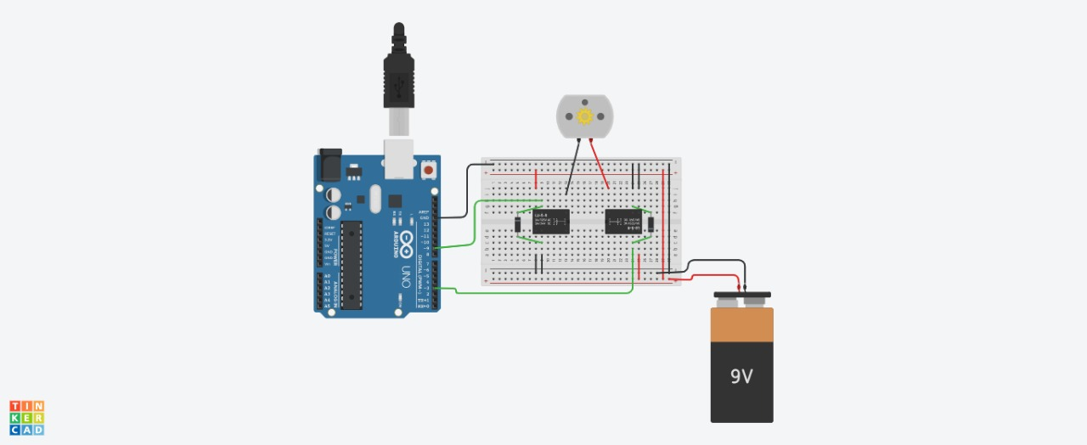 delay(500);

}